Mental Health Resources
Apps:
- Calm: The app delivers meditations that can help you to destress, as well as breathing programs, music, and sounds from nature to relax your mind and body and promote better sleep.
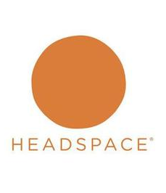

- Headspace: Headspace uses mindfulness and meditation to help you perform at your best each day. The app's mission is to provide you with the essential tools to achieve a happier, healthier life.

- Moodpath: Moodpath asks daily questions in order to assess your well-being and screen for symptoms of depression. The screening progress aims to increase your awareness of your thoughts, emotions, and feelings.

- Pacifica: Pacifica helps you to break cycles of unhelpful thoughts, feelings, and behaviors through methods such as CBT, mindfulness meditation, mood tracking, and relaxation.

- Superbetter: The app will help you to adopt new habits, improve your skills, strengthen relationships, complete meaningful projects, and achieve lifelong dreams.
- 7 Cups: It provides online therapy and emotional support for anxiety and depression.There are more than 160,000 trained listeners and licensed therapists who are available to anonymously speak with 24/7. Speak your mind and confide in listeners without the fear of being judged.
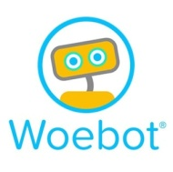
- Happify: The app offers activities and games to improve your life satisfaction and ability to fight negativity. Your emotional well-being is calculated as a happiness score that you can improve upon each week.

- Woebot: The app offers a way to think through situations with step-by-step guidance from Woebot using methods from CBT and learn about yourself with intelligent mood tracking.
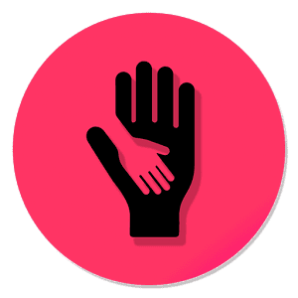
- What’s Up: What's Up? is a fantastic free app utilising some of the best CBT (Cognitive Behavioural Therapy) and ACT (Acceptance Commitment Therapy) methods to help you cope with Depression, Anxiety, Anger, Stress and more! With a beautiful, modern design, simple heading and easy-to-follow methods, you can get to what helps you the most in seconds!

